Research Blueprint: Automated Acronym Understanding and CCC-Based Concept Mapping

Consolidated Literature Comparison, Research Gap, and Proposed Solution

Purpose of This Document
This document is the research blueprint deliverable: a consolidated comparison of 22 research papers relevant to acronym/abbreviation identification, disambiguation, and concept/knowledge organization, followed by an identified research gap and a pro-posed solution. The full comparison table (with all six required columns for each pa-per) is provided as a companion spreadsheet, Consolidated_Paper_Comparison.xlsx, since a 22-row x 6-column table is more usable there than compressed into a PDF page. This document summarizes that table, groups the papers by Paper Set, and builds the gap analysis and proposed solution directly from it.

Consolidated Comparison — Summary by Paper Set
22 papers were reviewed, spanning four Paper Sets relevant to the proposed system. Full detail (what was done, how, dataset, advantages, limitations) is in the spreadsheet; this section groups and summarizes them.

Paper Set A — Scientific Acronym Identification & Disambiguation (6 pa-pers)
Veyseh et al. 2020 (SciAI/SciAD, GAD); Zhu et al. 2021 (AT-BERT); Veyseh et al. 2021 (MadDog); Pan et al. 2021 (multi-strategy SciBERT); Zhong et al. 2021 (hdBERT); Egan & Bohannon 2021 (Primer AI, SciAD-dedupe).
These establish the core scientific-domain benchmarks (SciAI, SciAD) and the strongest reported models: adversarially-trained/ensembled BERT for identifica-tion (94.12 F1) and dual-path or multi-strategy transformers for disambiguation (93.7–94.1 F1), against a human ceiling of ~96% F1.

Paper Set B — Clinical/Biomedical Abbreviation Detection & Disambigua-tion (8 papers)
Zilio et al. 2022 (PLOD); Wagh & Khanna 2023 (Clinical BERT variants); Wen, Lu & Reddy 2020 (MeDAL); Skreta et al. 2021 (ontology-aware CNN); JMIR 2024 (One-to-All BlueBERT); Adams et al. 2020 (Latent Meaning Cells, zero-shot); 2024 PubMed (LLM zero-shot clinical disambiguation).
This Paper Set shows the same AI/AD problem re-solved repeatedly in the clinical/biomedical domain, with larger raw datasets (MeDAL: 14.3M articles; PLOD: 160K+ segments) but the same ceiling pattern — strong accuracy on narrow candidate sets, degrading on longer documents (512-token BERT limits) or unseen acronyms (motivating zero-shot approaches).

Paper Set C — Knowledge Graph / Concept Map Construction (6 papers)
Zhong et al. 2023 (KGC survey); Yang et al. 2024 (Graphusion); NLP-AKG 2025; Sahrawat et al. 2019 (keyphrase extraction); GT-D2G 2022; Automated Concept Map Extraction 2024.
This Paper Set shows the tools that exist for turning free text into structured concepts and graphs — including two papers (Graphusion, NLP-AKG) that build knowledge graphs specifically for NLP/CS research papers — but none of them start from resolved acronyms; they extract concepts from raw text directly and do not address the abbreviation-expansion step at all.

Paper Set D — Taxonomy / Hierarchy Construction (3 papers)
Mao et al. 2018 (TaxoRL); Zhang et al. 2018 (TaxoGen); Shang et al. 2018 (HiExpan).
These provide general-purpose algorithms for building a hierarchy from a term set (reinforcement learning, clustering, seed expansion) but assume the term set is al-ready given — they do not identify or disambiguate the terms themselves, and are not applied to abbreviations.

Research Gap (Derived from Limitations)
Reading across all 22 papers’ limitation columns, four repeating gaps emerge:
- Paper Sets A and B (14 papers) solve identification/disambiguation but stop there. Every acronym/abbreviation paper — scientific or clinical — outputs, at best, a single resolved long form per acronym. None link that result onward into a concept, a category, or a hierarchy. (Papers 1–11, 21, 22 in the table.)
- Paper Sets C and D (9 papers) solve concept/knowledge organization but never start from abbreviations. Knowledge-graph and taxonomy papers (12–20) extract concepts or build hierarchies from raw text or a pre-given term list
— none take a resolved acronym as the starting node of a concept chain.
- No paper in either group performs CCC-style (Concept–Category–Context) mapping. Even the most relevant knowledge-graph paper for this domain, Graphusion (13), builds general NLP-concept graphs from lecture/paper text — not from disambiguated abbreviations, and with no explicit “Category” layer or per-concept provenance/context field.
- No paper combines interactive visualization with abbreviation resolution. MadDog (3) is the only deployed, multi-domain abbreviation tool, and it offers direct lookup only — not a visual, explorable concept structure. The concept-map papers (16, 17) do visualize output, but disconnected from any abbreviation pipeline.

Research Gap Statement:
Across 22 reviewed papers spanning scientific and clinical acronym resolution, scientific/general knowledge-graph construction, and text-based taxonomy induction, no single system takes an abbreviation from raw text all the way through disambiguation into a structured, hierarchical, and visually explorable concept representation. Abbreviation-resolution research (14 of 22 papers) treats its output as a terminal flat label. Knowledge-organization research (9 of 22 papers, with 1 paper — Graphusion — appearing in both groups’ adjacent space) treats concept/entity extraction as a separate prob-lem starting from raw text or a pre-given term list, never from a resolved abbreviation. The result is a clear, unaddressed gap between accurate ab-breviation resolution and usable, structured, explorable document under-standing.

Proposed Solution

What Is Required
To close the gap identified above, the proposed system must add a bridging layer that today’s literature does not provide:
    - A concept-extraction step that maps a resolved abbreviation’s long form onto a broader concept (not addressed by any Paper Set A/B paper).
    - A CCC (Concept–Category–Context) mapping mechanism that assigns each concept a category and retains the originating sentence/document as provenance (not addressed by any THC/D paper; closest analog is Graphusion’s entity/relation extraction, but without an abbreviation-resolution front end or an explicit category/context layer).
    - A hierarchy-generation step reusing established taxonomy-construction techniques (Paper Set D: TaxoRL, TaxoGen, HiExpan) — but applied to concepts derived from abbreviations rather than a pre-given term list.
    - A knowledge graph and interactive visualization layer, informed by Paper Set C tooling (NetworkX-style graph construction, PyVis/D3.js-style rendering as in the concept-map papers) but applied end-to-end from PDF input rather than as a standalone concept-mapping exercise.

How to Tackle Each Limitation

Limitation (from the table) Tactic

AI/AD models plateau below human performance (Paper Set A, papers 1–6)
Reuse the strongest reported components directly rather than re-deriving them:
SciBERT/AT-BERT-style identification (94.12 F1) and
hdBERT/multi-strategy-style disambiguation (93.7–94.1 F1) as the
front-end, rather than attempting to beat state-of-the-art AI/AD accuracy — the
novelty is downstream, not in re-solving AI/AD.

Limitation (from the table) Tactic

BERT’s 512-token limit truncates long documents (papers 8, 11)

Small/ambiguous candidate sets,
domain-specific brittleness (papers 8, 21,
22, clinical Paper Set)

Concept/KG extraction methods start from raw text or a pre-given term list, never a resolved abbreviation (Paper Set C/D, papers 12–20)

Duplicate/conflicting benchmark labels bias evaluation (paper 6)

No paper visualizes abbreviation-derived concepts (papers 3, 16, 17)

KG construction methods risk LLM hallucination when using LLM-based triplet extraction (paper 13)
Process per-section/per-sentence rather than whole-document, consistent with
how the reviewed AI/AD papers already operate (sentence-level context
windows), and retain section-level
provenance for the CCC “Context” field. Scope the initial system to the AI/CS scientific domain (Paper Set A datasets),
where SciAI/SciAD/PLOD already
provide larger, cleaner-benchmarked data than clinical alternatives; domain extension is a later-phase option, following MadDog’s (paper 3) demonstrated multi-domain feasibility. Insert concept extraction and CCC mapping directly after the AD module’s output, using dictionary lookup (seeded
from the abbreviation dataset itself) plus embedding-similarity fallback — closing exactly the gap these papers leave open. Use the already-deduplicated
SciAD-dedupe benchmark (paper 6’s contribution) for AD evaluation rather than raw SciAD.
Adopt the rendering approach of the concept-map papers
(PyVis/D3.js/Cytoscape-style interactive graphs) as the final pipeline stage, applied to the CCC/hierarchy output rather than a standalone text corpus.
Prefer deterministic dictionary/taxonomy lookups (Paper Set D style) for the CCC “Category” assignment where possible, reserving LLM-assisted extraction (Graphusion-style) only as a fallback for concepts not covered by the seed
taxonomy, with confidence thresholds and flagging for uncertain cases.

Dataset to Work Upon
Primary dataset selection, justified directly from the comparison table:
    - Acronym Identification training/evaluation: SciAI (paper 1) and PLOD (pa-per 7) — PLOD is larger (160K+ segments) and provides a useful cross-domain generalization check, since paper 7 already reports zero-shot testing against the

SDU shared-task (SciAI-derived) data.
    - Acronym Disambiguation training/evaluation: SciAD-dedupe (paper 6) rather than raw SciAD (paper 1), to avoid the duplicate/conflicting-label bias documented in paper 6.
    - Concept/Category seed taxonomy: a curated AI/CS concept taxonomy (e.g., ACM Computing Classification System), supplemented by the concept-category mappings already produced in this project’s Phase 5 seed dataset (Concepts.csv), and extendable via the embedding-similarity fallback described in 4.1.
    - Knowledge-graph/relationship validation reference: TutorQA (paper 13) is a useful external benchmark for sanity-checking that generated NLP-domain con-cept relationships are reasonable, even though it is not itself an abbreviation dataset.
This keeps the project inside the AI/CS scientific domain (matching this project’s Phase 1–6 scope) while pulling in the largest, cleanest, most recently validated datasets identified across all 22 papers, instead of only the original six.

Tentative Architecture / Flow
The reviewed literature maps cleanly onto a two-half pipeline: the first half consoli-dates Paper Set A/B’s strongest components, and the second half is the novel contribu-tion built to close the gap found in Paper Sets C/D.
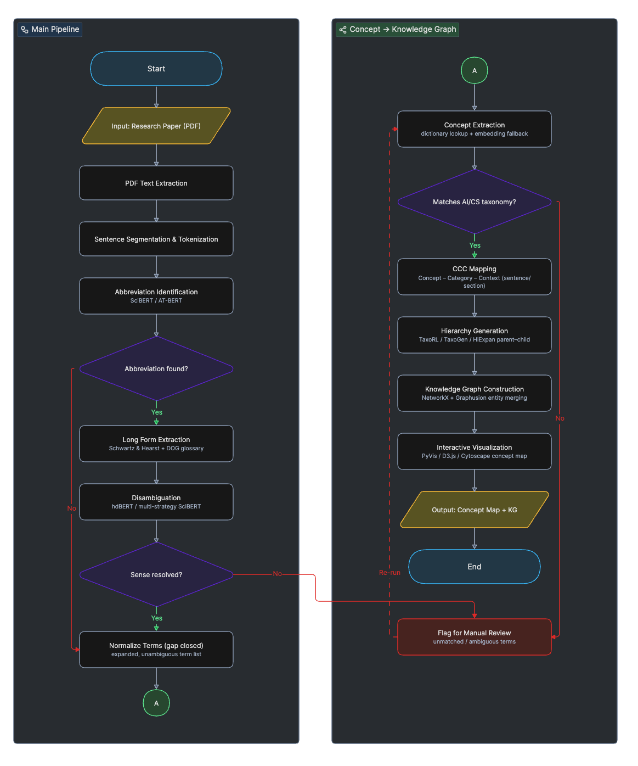
This is consistent with — and now evidence-grounded across 22 papers rather than 6 — the architecture already defined in this project’s Phase 4 (Proposed Methodol-ogy) and Phase 6 (Algorithm & Model Design) documents; those documents’ module designs and pseudocode remain valid and are the implementation-level detail behind each box above.

Companion File
Consolidated_Paper_Comparison.xlsx — the full 22-paper table with all five required columns (what work was done, how it was done, dataset used, advantages, limitations) plus paper metadata and focus-area tagging, filterable by column.

